**Module 1 ( Fundamentals)**

1. **What is S.D.L.C ?**

* Full form Software Development Life Cycle.
* A structure process that is used to design, define , develop and test good quality software.
* Goal :- Deliver high quality maintainable software that meets client requirements.

**Phase of software development life cycle:-**

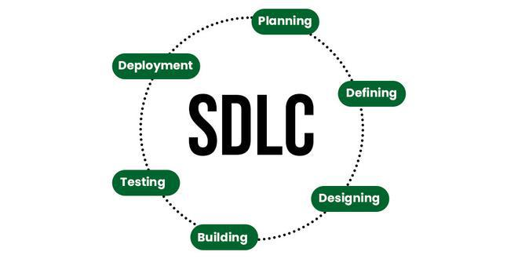

1. **What is software testing?**

* Testing of software by finding a bug in software.
* Its is process and not a single activity.
* Software testing begins in very early phase of sdlc.
* Testing checks the system or software operates according to clients requirements.
* Software testing checks the different between required and actual result in software, the difference is term as defects, error or bug which needs to be reported to developer so that he or she can debug it and system can run as per requirements.
* Early phase testing can prevent bugs to be indulge in code.

1. **What is Agile Methodology?**

* Agile Methodology is a project management & a software development approach.
* This methodology emphasize Flexibility. Collaboration and customer centricity.
* A latest model use by major companies like Facebook , google and amazon.
* It follows nitrative and incremental approach
* Agile focus on delivering small pieces of work instead of big bunch.
* It allows employees to adopt changes very quickly.

1. **What is S.R.S ?**

* **S.R.S** stands for Software requirement specification.
* It is complete specification & description of requirement of the software that needs to be fulfilled for the software development of software system.
* This can be functional or non functional as per requirement.
* Development team required to develop product according to needs and specification.
* It also has detailed specification about the cost it will take to develop a software with the time duration , so the project time lime is clear for both the side.
* It provide a proper road map for software development team.

1. **What is oops?**

* As the name suggests, Object-Oriented Programming or OOPs refers to languages that use objects in programming.
* The main aim of OOP is to bind together the data and the functions that operate on them so that no other part of the code can access this data except that function.
* Some of the object oriented languages age C++, java , python etc.

1. **What is basic concept of OOPs?**

* Class
* Objects
* Data Abstraction
* Encapsulation
* Inheritance
* Polymorphism
* Dynamic Binding
* Message Passing

1. **What is object?**
   * An object represents an individual, identifiable item
   * It can be either real or abstract in nature.
   * Any tangible things, roles, incident.
2. **What is class?**

* Class is a blueprint for creating objects.
* Classes are fundamental to OOP as they provide a way to structure and organize code in a modular and reusable manner.
* For e.g. there may car can be consider as class, there may be many cars but the brand may be different, there name may be different but all may have same properties like all will have 4 wheels, mileage, speedometer. Such specification will be considered as class properties.

1. **What is encapsulation**

* It’s a fundamental concept in object-oriented program, building data and methods that operate in the data in to single unit.
* Typically, this concept is for protecting data from unauthorised access and modification, enhancing code,
* Encapsulation ensure that the internal working of a class are hidden, promoting modular code.

**10.What is inheritance?**

* Inheritance is feature or a process in which, new classes are created from the existing classes.
* The new class created is called “derived class” or “child class” and the existing class is known as the “bass class” or “parent class”.
* The derived class now is said to be inherited from the base class.

**11.What is polymorphism?**

* The word polymorphism word means “having many forms”
* The ability to display message in many forms in java.
* Polymorphism allows us to perform a single action in different ways. In other words, polymorphism allows us to define one interface and have multiple implementations.

**12.** **Write SDLC phases with basic introduction.**

* **Requirement gathering and analysis:-** This phase involve gathering information about the software requirements from stakeholders , such as customer , end users and business analyst
* **Design:-**  In this phase , the software design is created , which includes the overall architecture of the software, data structure and interfaces.
* **Implementation or coding:** The design is then implemented in code, usually in several iterations, and this phase is also called as Development.
* **Testing:**The software is thoroughly tested to ensure that it meets the requirements and works correctly.
* **Deployment:** After successful testing, The software is deployed to a production environment and made available to end-users.
* **Maintenance:**This phase includes ongoing support, bug fixes, and updates to the software.

**13.** **Explain Phases of the waterfall model.**

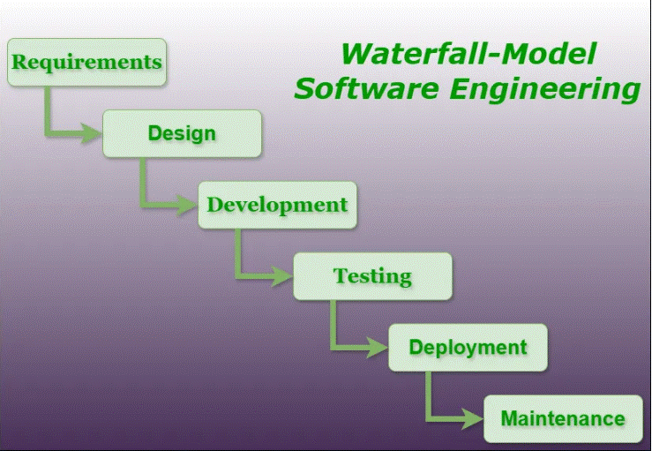

* **Requirement :** The first phase involve gathering requirements from stakeholders and analysin g them to understang the scope and objectives of the project.
* **Desing:** Once the requirements are understood, the design phase begins. This involves creating a detailed design document that outlines the software architecture , user interface and system components.
* **Development:** The development phase includes implementation involves coding the software based on the design phase specification. This phase also includes unit testing to ensure thar each components of the software os working as expected.
* **Testing:** in this testing phase , the software is tested as whole to ensure that it meets the requirements and is free from defects.
* **Deployment:** Once the so the software has been tested and approved , it is deployed to the production environment .
* **Maintenance:** The final phase of the waterfall model is maintenance, which involves fixing any issues that arise after the software has been deployed and ensuring that it continues to meet the requirement over time.

**14.** **Write phases of spiral model?**

* **Objective Defined:** In first phase of spiral model we clarify what the project aims to achieve , including functional and non functional req.
* **Risk Analysis**: in this phase the risk is associated with the project are identified and evaluated
* **Engineering:** in the engineering phase, the software is developed based on the requirements gathered in the previous iteration.
* **Evaluation:** in this phase , the software is evaluated to determine if it meets the customers req and if it is of high quality
* **Planning:** The next iteration of the spiral begins with a new planning phase, based on the results of the evaluation.

**15.** **Write agile manifesto principles.**

* Customer Satisfaction through Early and Continuous Delivery
* Welcome Changing Requirements, Even Late in Development
* Deliver Working Software Frequently
* Collaboration between Business Stakeholders and Developers
* Build Projects around Motivated Individuals
* Face-to-face communication is the Most Effective
* Working Software is the Primary Measure of Progress
* Maintain a Sustainable Pace of Work
* Continuous Attention to Technical Excellence and Good design
* Simplicity—the Art of Maximizing the Amount of Work Not Done
* Self-Organizing Teams
* Regular Reflection on Team Effectiveness

**16.** **Explain working methodology of agile model and also write pros and cons.**

* Agile model is combination of iterative and incremental model
* Objective here is adaptability and customer satisfaction .
* The delivery here is rapid for the software product.
* This model break the software in to small incremental builds.
* These build are provided in iteration (repeating the process).
* At the end of the iteration the product is been shown to customer , stakeholder.

**Pros:-**

* Very realistic approach.
* Promote team work and cross training
* Functionality are developed and delivered rapidly.
* Suites changing requirements.

**Cons:**

* Not suitable for complex dependency.
* Strict delivery management dictates the scope, functionality to be deliver on time to meat the deadline.
* Depends heavily on customer interaction.( so if customer is not clear team can move in wrong path)
* Mini documentation.
* Transfer of technology to new team member is quit challenging as there is less documentation.

**17 Draw usecase on OTT Platform.**

* [**https://drive.google.com/file/d/1lGV5YEBrewcxodiQvSwHSgxuEz6QJGKb/view?usp=drive_link**](https://drive.google.com/file/d/1lGV5YEBrewcxodiQvSwHSgxuEz6QJGKb/view?usp=drive_link)

**18 Draw usecase on E-commerce application.**

* <https://drive.google.com/file/d/1CTBzAl42mb8iMDd5B_CVef6Y50F_--PG/view?usp=drive_link>

**19. Draw usecase on Online shopping product using payment gateway**

* [**https://drive.google.com/file/d/1BF_r0ME-6SxaiQcWvlgHJytq6kkusTiD/view?usp=drive_link**](https://drive.google.com/file/d/1BF_r0ME-6SxaiQcWvlgHJytq6kkusTiD/view?usp=drive_link)

**20.Draw Usecase on online bill payment system (paytm)**

* [**https://drive.google.com/file/d/1Vc952tB9IeORx44XpeXLdMY6kJLgniSo/view?usp=drive_link**](https://drive.google.com/file/d/1Vc952tB9IeORx44XpeXLdMY6kJLgniSo/view?usp=drive_link)

**21.Draw Usecase on banking system for customers.**

* [**https://drive.google.com/file/d/1mzHDho63cqjvc2eI6LtAsy3I5smi4MRK/view?usp=drive_link**](https://drive.google.com/file/d/1mzHDho63cqjvc2eI6LtAsy3I5smi4MRK/view?usp=drive_link)

**22. Draw Usecase on Broadcasting System**

* [**https://drive.google.com/file/d/1uaM4XEWjbNzUaaeljnxnOYQBgqdN6YpN/view?usp=drive_link**](https://drive.google.com/file/d/1uaM4XEWjbNzUaaeljnxnOYQBgqdN6YpN/view?usp=drive_link)

**Thank you**